**Project 2: Supernova Cosmology Project Handout**

This handout is based on the analysis conducted in the Jupyter Notebook titled '2_hubble_parameter.ipynb'. You are expected to run the notebook based on the instructions, review the plots and results, and answer the following questions based on your findings.

Try to mention your approach for the tasks, relevant plots, and answers here, attaching the notebook as a PDF (you can do the same from Jupyter)

# Questions

1. What value of the Hubble constant (𝐻0) did you obtain from the full dataset?

Ans:- From the full dataset, the value of the Hubble constant $H_{0}$

$$H_{0}=72.97 ± 0.26 km/s/Mpc$$

1. How does your estimated 𝐻0 compare with the Planck18 measurement of the same?

Ans:- The Planck18 mission measured $H_{0}=67.4 km/s/Mpc$ based on observations of the cosmic microwave background (CMB). In comparison, my fitted value of 72.97 km/s/Mpc is higher than the Planck18 value. This difference reflects the “Hubble tension” (refers to a discrepancy in the measured rate of the universe's expansion), ongoing disagreement between early universe (CMB) and late-universe (supernovae) measurements of the Hubble constant.

1. What is the age of the Universe based on your value of $H_0$? (Assume Ω𝑚 = 0.3 ). How does it change for different values of Ω𝑚?

Ans:- The age of the Universe based on my model is 12.36 Gyr.

Let's assume Ω𝑚 = 0.3, then the Age of the Universe is 12.92 Gyr.

As the Ω𝑚 increases, the age of the universe decreases. Ω𝑚 is inversely proportional to the age of the universe. For higher Ω𝑚, the Universe appears younger and vice versa

Ω𝑚 = 0.24, then the Age of the Universe is 13.73 Gyr

Ω𝑚 = 0.26, then the Age of the Universe is 13.44 Gyr

Ω𝑚 = 0.28, then the Age of the Universe is 13.17 Gyr

Ω𝑚 = 0.32, then the Age of the Universe is 12.69 Gyr

Ω𝑚 = 0.34, then the Age of the Universe is 12.47 Gyr

Ω𝑚 = 0.36, then the Age of the Universe is 12.27 Gyr

1. Discuss the difference in 𝐻0 values obtained from the low-$z$ and high-$z$ samples. What could this imply?

Ans:- The dataset was split into Low-z supernovae (z < 1) and High-z supernovae (z ≥ 1).

Low-z (z < 0.1): H₀ = 72.74 ± 0.59 km/s/Mpc

High-z (z ≥ 0.1): H₀ = 73.18 ± 0.50 km/s/Mpc

The difference is small, but it shows that the value of H₀ changes a little depending on which part of the Universe we look at. This could be due to local effects, small errors in the data, or even hints that the expansion of the Universe has changed over time.

1. Plot the residuals and comment on any trends or anomalies you observe.

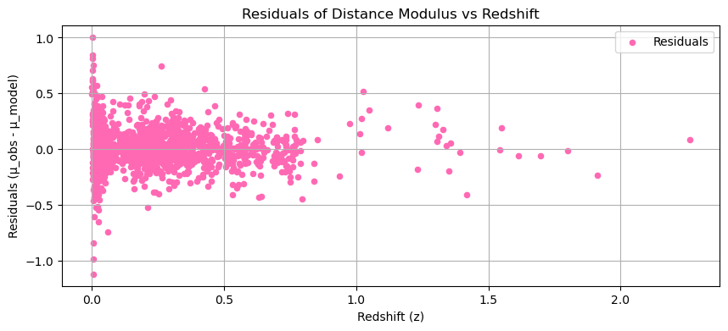Ans:-

The residuals plot shows that differences between observed and predicted distance modulus values are randomly scattered around zero across all redshifts, indicating a good fit with no systematic biases, despite a few outliers at higher redshifts due to larger uncertainties. The lack of a pattern supports the model's reliability and accurate description of the supernova data.

1. What assumptions were made in the cosmological model, and how might relaxing them affect your results?

Ans:- This project adopts a flat ΛCDM cosmological model, where dark energy is modelled as a cosmological constant and matter is the primary other component. It also presumes the supernovae used are standard candles and that the dark energy equation of state remains unchanged. Altering these assumptions, such as considering evolving dark energy, curvature, or non-standard supernova behavior, could modify the estimated H₀ and Universe age, possibly easing discrepancies between various datasets.

1. Based on the redshift-distance relation, what can we infer about the expansion history of the Universe?

Ans: - The redshift-distance relation indicates that the Universe is expanding, and this expansion has been accelerating over time. Supernovae observed at higher redshifts appear farther away than they would in a Universe that is expanding uniformly, providing strong evidence for the existence of dark energy. This acceleration in the expansion suggests that the history of the Universe includes a transition from a phase of deceleration, dominated by matter, to a current phase of acceleration driven by dark energy.

**Your Analysis & Notes**

Use the space below to attach any key plots, calculations, or notes from your analysis.

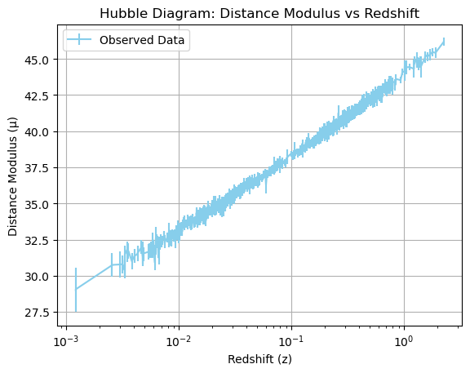Plot 1: Redshift vs. Distance Modulus

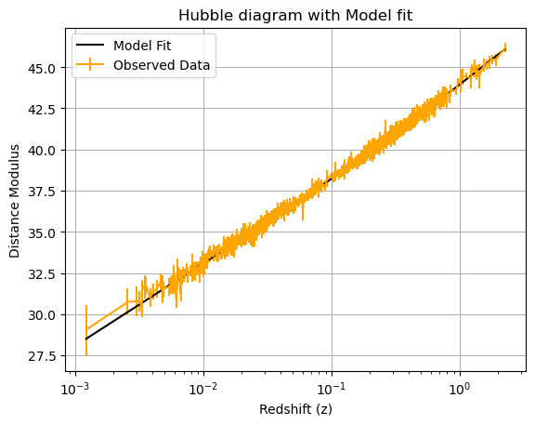Plot 2: Hubble Diagram with Model Fit

Plot 3: Plot the residual

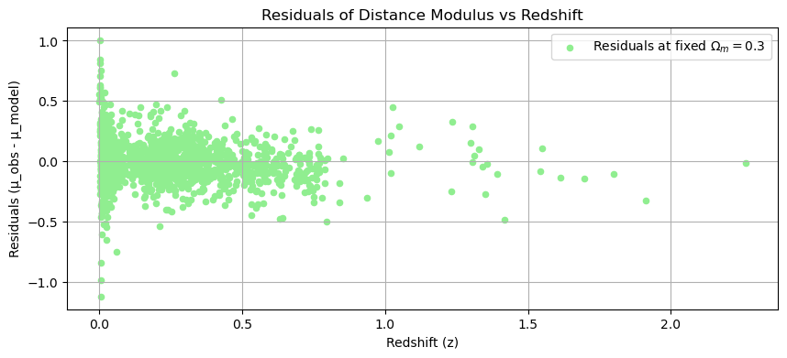

Both plots look very similar overall, with residuals mostly centered around zero, but in the first plot, the spread appears slightly tighter and more balanced at higher redshifts. This suggests that allowing Omega_m to vary gives a slightly better fit to the data, especially for distant supernovae, reducing systematic deviations.